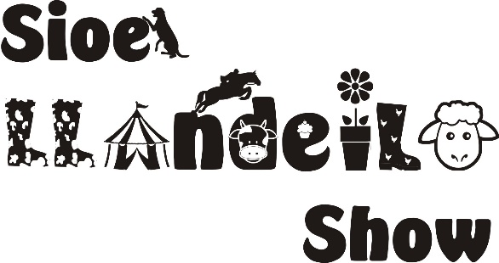 | Cymdeithas Sioe Amaethyddol & Garddwriaeth Llandeilo a’r Cylch  Llandeilo & District Agricultural & Horticultural Society

FFURFLEN GYSTADLU’R ADRAN ANIFEILIAID
LIVESTOCK ENTRY FORM

Enw'r Arddangoswr / Exhibitor's Name: __________________________________________
Cyfeiriad / Address: __________________________________________________________
__________________________________________________________________________
_______________________________________ Côd Post / Post Code: ________________
Ffôn / Tel: ___________________________
E-bost / E-mail: ______________________________________________________________
COFRESTR DIOGELU DATA GYFFREDINOL / GENERAL DATA PROTECTION REGISTER

Mae’n ofynnol i bob arddangoswr lenwi’r manylion uchod.
Wrth arddangos yn Sioe Llandeilo, rydych yn cytuno i gadw a defnyddio'ch data personol mewn dogfennau sy'n gysylltiedig â’r sioe, ac at ddibenion marchnata. Ni fyddwn yn trosglwyddo'ch gwybodaeth i unrhyw barti allanol.

Os nad ydych am i ni ddefnyddio’ch data, plis ticiwch y bocs.

All exhibitors must complete the above information.
In exhibiting at Llandeilo Show, you agree to the retention and use of your personal data in show-related documentation, and for marketing purposes. We will not pass your information to external / third parties.

If you would prefer your data is not used, please tick this box.

Hoffwn wneud y cofnodion drosodd ar gyfer y Sioe uchod, ar fy risg fy hun, ac yn amodol ar Reolau a Rheoliadau'r Gymdeithas, ac rwy'n cytuno i gydymffurfio â Rheolau, Rheoliadau ac Amodau'r Gymdeithas

I wish to make the entries overleaf for the above Show, at my own risk, and subject to the Rules & Regulations of the Society, and I agree to conform to the Society’s Rules, Regulations and Conditions

Arwyddwyd / Signed: _____________________________ Dyddiad / Date: ___/___/______

FFURFLEN GYSTADLU’R ADRAN ANIFEILIAID
LIVESTOCK ENTRY FORM
Please read through the rules and regulations of the society carefully before filling in the form.

- MEMBERS AND NON-MEMBERS WILL BE ALLOWED TO COMPETE FOR THE PRIZE MONEY. NO ENTRY FEES (UNLESS OTHERWISE NOTED), WITH THE EXCEPTION OF THE FIRST AID COVER CHARGE AT £2 PER EXHIBITOR
- NO FREE PASSES WILL BE ISSUED AND ALL EXHIBITORS, DRIVERS OF ALL VEHICLES AND VISITORS TO THE SHOW GROUND WILL BE REQUIRED TO PAY THE SHOW ADMISSION FEE, INCLUDING SHOW JUMPERS

ENTRIES TAKEN ON THE DAY, BUT ENTRIES WILL PREFERABLY BE ACCEPTED BY POST
UP TO 7 DAYS PRIOR TO THE SHOW. (See Rules)
Please return your completed forms to:

Cattle / Sheep & Goat Entries to: Mrs Jenni Jenkins, 41 Heol Cennen, Ffairfach, Llandeilo
SA19 6UL 07989 581527 livestock@sioellandeiloshow.org.uk

Class No. | Name / Type of Exhibit (animal) | Breed

Cheques payable to: Llandeilo and District Agricultural and Horticultural Society or
BACS: Barclays Bank 20:18:54 Acc No: 43270769

